AFP New Orleans Presentation
May 12, 2022

Dr. Halima Leak Francis
Public Administration Program Director and Professor of Practice
Tulane School of Professional Advancement

Thriving in the Face of Professional Uncertainties
Events of the last few years have prompted many to look closely at the balance of their career paths and personal fulfillment. The same holds true for nonprofit fundraisers and philanthropy professionals whose work has arguably become more-so critical to the well-being of individuals and communities. This reality presents us with the challenge of how to successfully navigate career demands and aspirations in unpredictable and sometimes high-stress environments. This session will explore how present-day issues such as the Great Resignation stand to impact the work of nonprofits and philanthropy. In doing so, Dr. Leak Francis will also speak to how nonprofit fundraising professionals can cultivate fulfilling careers even in the most challenging of times.
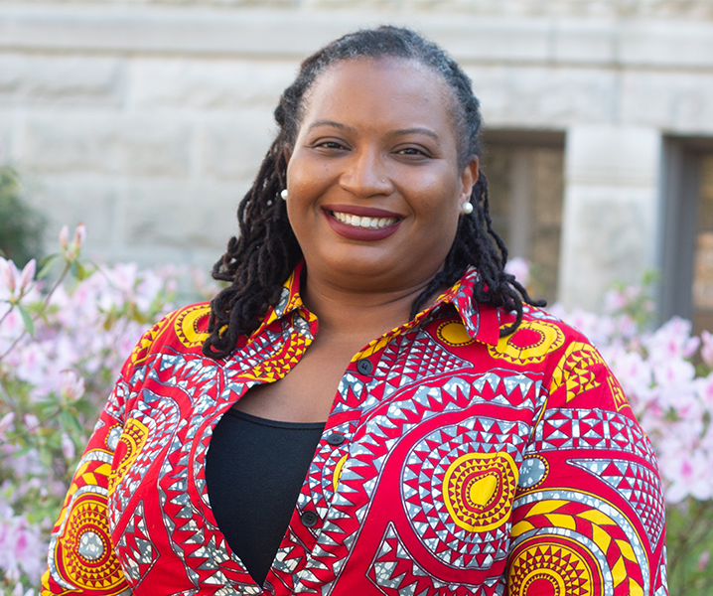
About Dr. Halima Leak Francis
Dr. Halima Leak Francis (she / her) is the founding Director and Professor of Practice of the Tulane University School of Professional Advancement Public Administration Program. Nationally accomplished, her career spanning more than 20 years has focused on strengthening capacity and equitable practices within nonprofits, philanthropy, higher education, and civic sector leadership. A dedicated community volunteer, she prioritizes advancing systemic equity and inclusion by supporting organizations that are committed to the same. Dr. Leak Francis holds a B.A. in English from Hampton University, an M.A in Sociology of Education and a Ph.D. in Higher Education Administration from New York University.

