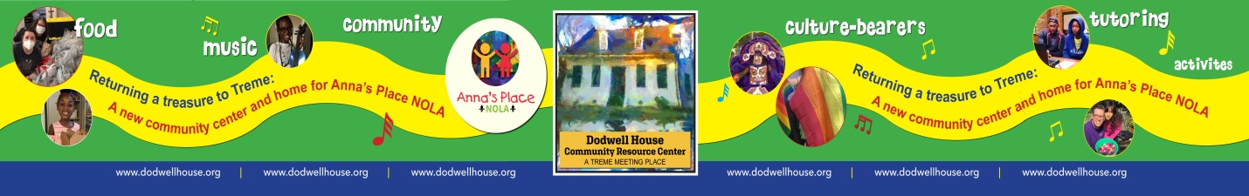

Job title Development Director
Company St. Anna's Episcopal Church in New Orleans
Job location 1313 Esplanade Avenue
New Orleans, LA 70116
Remote work allowed: Temporarily due to COVID-19
Pay and Benefits $50,000.00 - $75,000.00 per year
Benefits: Dental insurance, Disability insurance, Health insurance, Life insurance, Paid time off, Paid Vacation, Retirement plan and the work expectations are normal office hours or as may be required.

WHO WE ARE:
Saint Anna’s Episcopal Church is located in the Treme community. After Hurricane Katrina it became vested in community service and outreach. Our work does not seek to proselytize but we do hope to improve the lives and conditions of those who are marginalized, underserved, or at risk. We do this through the principal work of Anna’s Place NOLA, an out-of-school program and The Dodwell House Community Resource Center, a facility currently being developed to serve our wider neighborhood, culture bearers, and children. For Further information here are our websites: www.dodwellhouse.org, www.annasplacenola.org, www.stannanola.org
POSITION SUMMARY:
This is a new position for our team and this opportunity offers an individual the space to develop a robust Development plan. The Director of Development will be responsible for planning, organizing, and directing all of Saint Anna’s community based outreach fundraising (with emphasis on Anna’s Place NOLA and Dodwell House Community Resource Center) including a major gifts program, annual fund, planned giving, special events and capital campaigns. The Director works closely with The Rector, Anna’s Place Director and the Board of Directors (Vestry) in all development and fundraising endeavors. This is a full-time, salaried position. [Note: This position is not responsible for normal church operating funds or church/worship related capital campaigns.]

QUALIFICATIONS:
- Must embrace the mission of Anna’s Place NOLA and The Dodwell House Community Resource Center.
- Strong interpersonal and writing skills.
- Have knowledge and experience in fundraising techniques, particularly major gift fundraising.
- Have the desire to get out of the office and build external relationships.
- Possess the skills to work with and motivate staff, board members and other volunteers.
- Be a “self-starter” and goal driven to initiate donor visits and fundraising calls.
- Be organized and exhibit “follow through” on tasks and goals.
- Display a positive attitude, show concern for people and community, demonstrate presence, self-confidence, common sense and good listening ability.
- Minimum Bachelor's degree
- Minimum 3 years experience in professional fundraising
Responsibilities
- Meet prospective donors and supporters on a continual basis to establish effective communications with them.
- Research, identify and cultivate new prospects
- Oversee grant seeking including research, proposal writing, and reporting requirements.
- Grow a Major Gifts program including identification, cultivation and solicitation of major donors.
- Build the Planned Giving program including deferred gifts such as bequest expectancies.
- Direct all major fundraising drives, including, but not limited to, annual and employee drives.
- Coordinate fundraising special events.
- Work closely with The Rector, Anna’s Place Executive Director, and Board of Directors (Vestry).
- Make public appearances/accept speaking engagements to share information about Anna’s Place NOLA/Dodwell House Community Resource Center with the community.
- Maintain fundraising database and tracking systems.
- Maintain gift recognition programs.
- Prepare or coordinate the creation of publications to support fund raising activities.
- Staff Board Development Committee meetings.
- Supervise and collaborate with other fundraising staff.
- Demonstrate professional conduct at all times.
- Perform other related duties as requested.

How to apply: (Interviews may be in persona and or Zoom)

- Send a cover letter along with your resume to fr.bill@stannanola.org or via mail.
- We promise to respond within 72 hours with a notification of status.
- If we move to the interview stage there will be an initial interview with the Rector.
- If we move beyond the initial interview a second interview with a development team will be scheduled

Application questions:

- What is the highest level of education you have completed?
- How many years of professional fundraising experience do you have?
- Please list 2-3 dates and time ranges that you could do an interview.
- "What is it about our organization and this job description that makes you want to work here?"
- Please provide at least two professional references and one personal reference.
-
Expected Hiring Date 2 to 4 weeks

