Clark Gafke
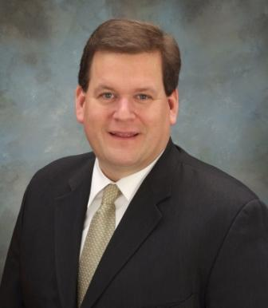
In his 30-years providing fundraising counsel, Clark has served 211 organizations in the US and Canada representing youth, education, healthcare, arts and museums, zoos and aquariums, public broadcasting and membership organizations. In the process, he’s trained and coached more than 11,000 fundraising communicators. Beyond this direct service to organizations, he is a frequent speaker at fundraising conferences including NCDC, CASE, AFP, PCI and on many college campuses. He is Past President of the Las Vegas AFP Chapter, a former national delegate, and Past Chair of the chapter’s Education Committee and Every Member Campaign. Clark is also a CASE Currents contributor. Currently, Clark is a member of both the Las Vegas AFP and St. Louis AFP Chapters. He has also served on the program committee for the New Orleans AFP Chapter.

